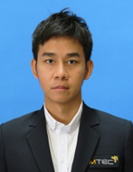**Pornpipat Yoosa**

**24 October 1985 (30ys), Single**

[**pornpipatyoosa@gmail.com**](mailto:pornpipatyoosa@gmail.com)

**Mobile : 66+94-494-0112**

**Current Address :** 9/131 Pruksa Vill8/2 , See-gun, Songpapha Rd, Donmuang Bangkok 10210  
**Office :** National Metal and Materials Technology Center(MTEC).   
 National Science and Technology Development Agency (NSTDA) 114 Thailand Science Park,  
 Phahonyothid Rd. Khlong Nueng, Khlong Luang, Pathum Thani 12120

**EDUCATION AND CERTIFICATIONS**

**Naresuan University** B.S. Engineer, Mechanical Engineering

GPA : 2.86 2003-2007

**Tokyo Japanese Language Education Center Japan** Japanese Intensive Course

Japanese language Skill (N2) 2009 – 2010

**Tokyo Institute of technology** Research Student

Fundamental of gasification technology 2010 – 2011

**Kyushu University** M.A. Interdisciplinary of Engineering Science, Energy and Environmental Engineer

GPA : 3.50 ( Solar-thermal Desiccation cooling system) 2011-2013

**Related Experience**

**Bridgestong Co.,Ltd (2007-2008) : Process Engineer ,**

Assurance on the control system in manufacturing plants producing bias tires and resolve any trouble process in production line.

**National Metal and Materials Technology Center (MTEC).**

Conducting wastes from oil palm extraction process and other potential biomass which capable to produce thermal energy for using in extraction process.

Study microwave drying technique for making suitable oil palm quality in commercial process.

**Research Project**

1. Investigating quality of producer gas from gasifier-kit (10kW) with empty fruit bunches.
2. Desing and Fabrication of Crossdraft Gasifier with 400kg/hr as thermal source for replacement of LPG utilization in steamless palm oil extraction system.
3. Preservation of oil palm fruit by microwave sterilization.

**Research Topic in PhD course \*\***

To conduct several byproduct from steam-less oil palm extraction process such bunch, kernel shell, palm press fiber and palm kernel cake for energy conversion in term of heat. By focusing to research and fabricate a suitable configuration type of gasifier which can be responded to

1. Preventing bed agglomeration due to mainly constituent of Potassium in order to reliable operation.
2. Following (I), study the effects of overall efficiency in various operating condition and mixing of bed material composition.
3. Base on the result of (I and II), comparing the result from simulation software and experiment in order to investigate a concentration of producer gaseous.

**Research study and activities**

* **Up draft gasifier testing with two discrepant EFB (steam-less EFB and steam EFB) as initial fuel.**

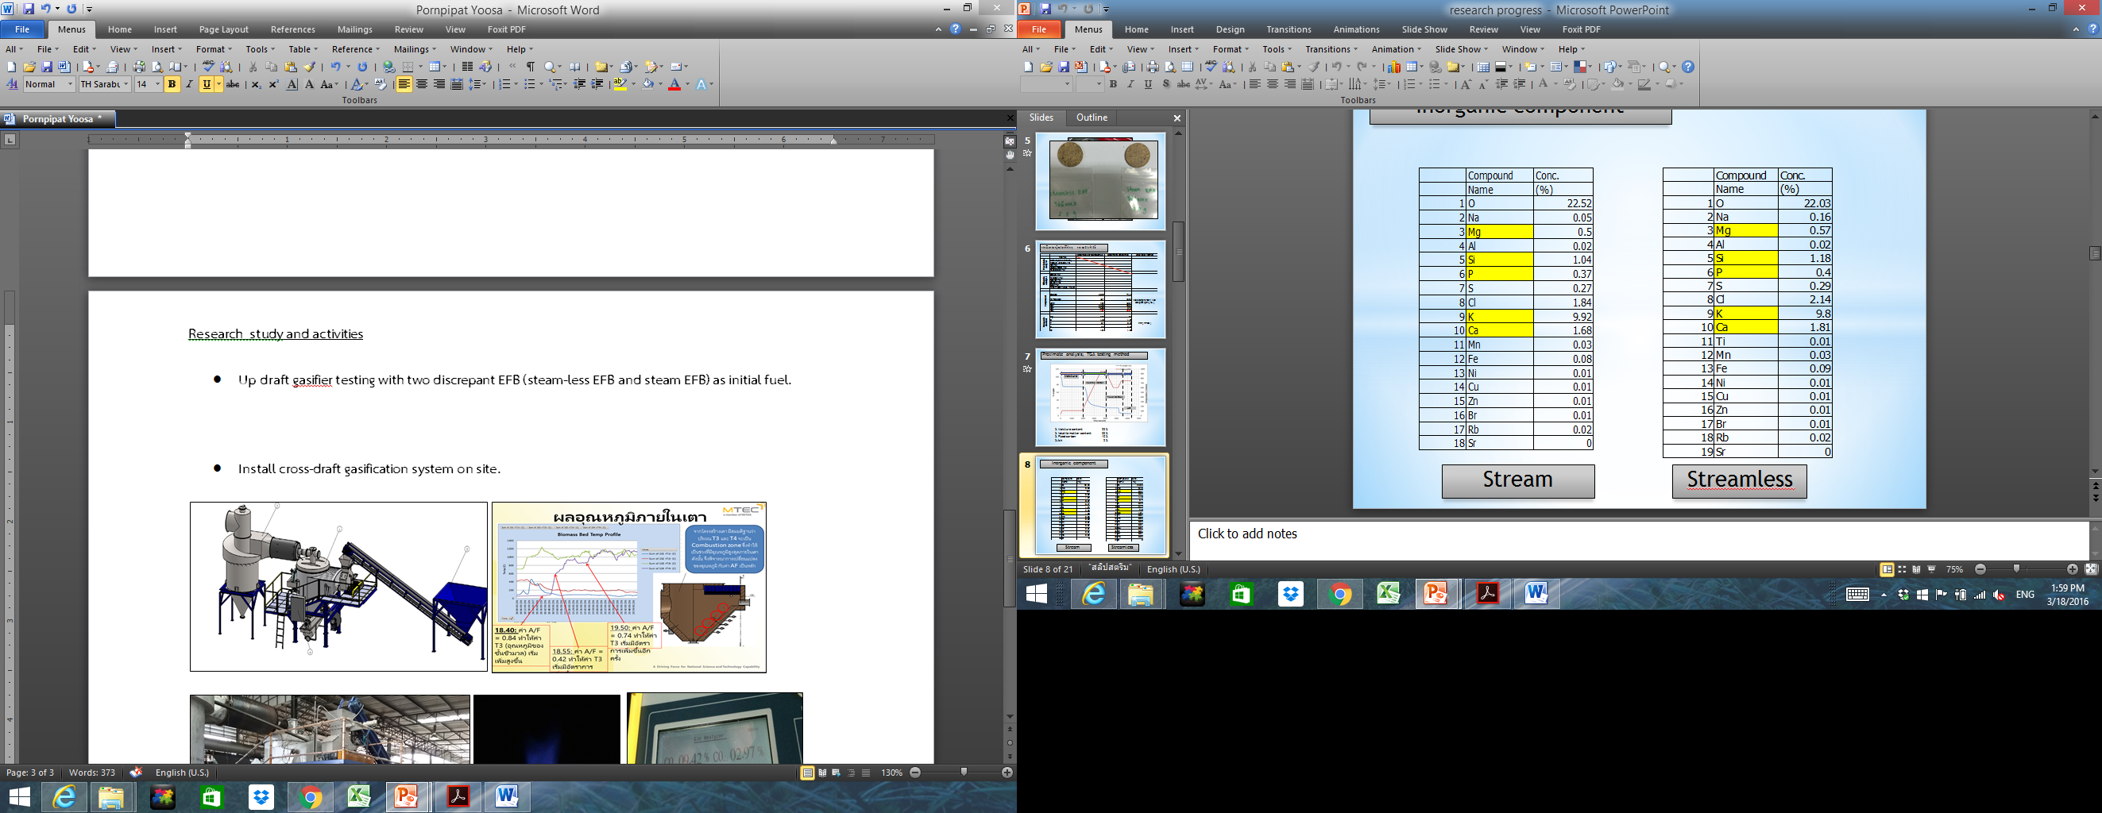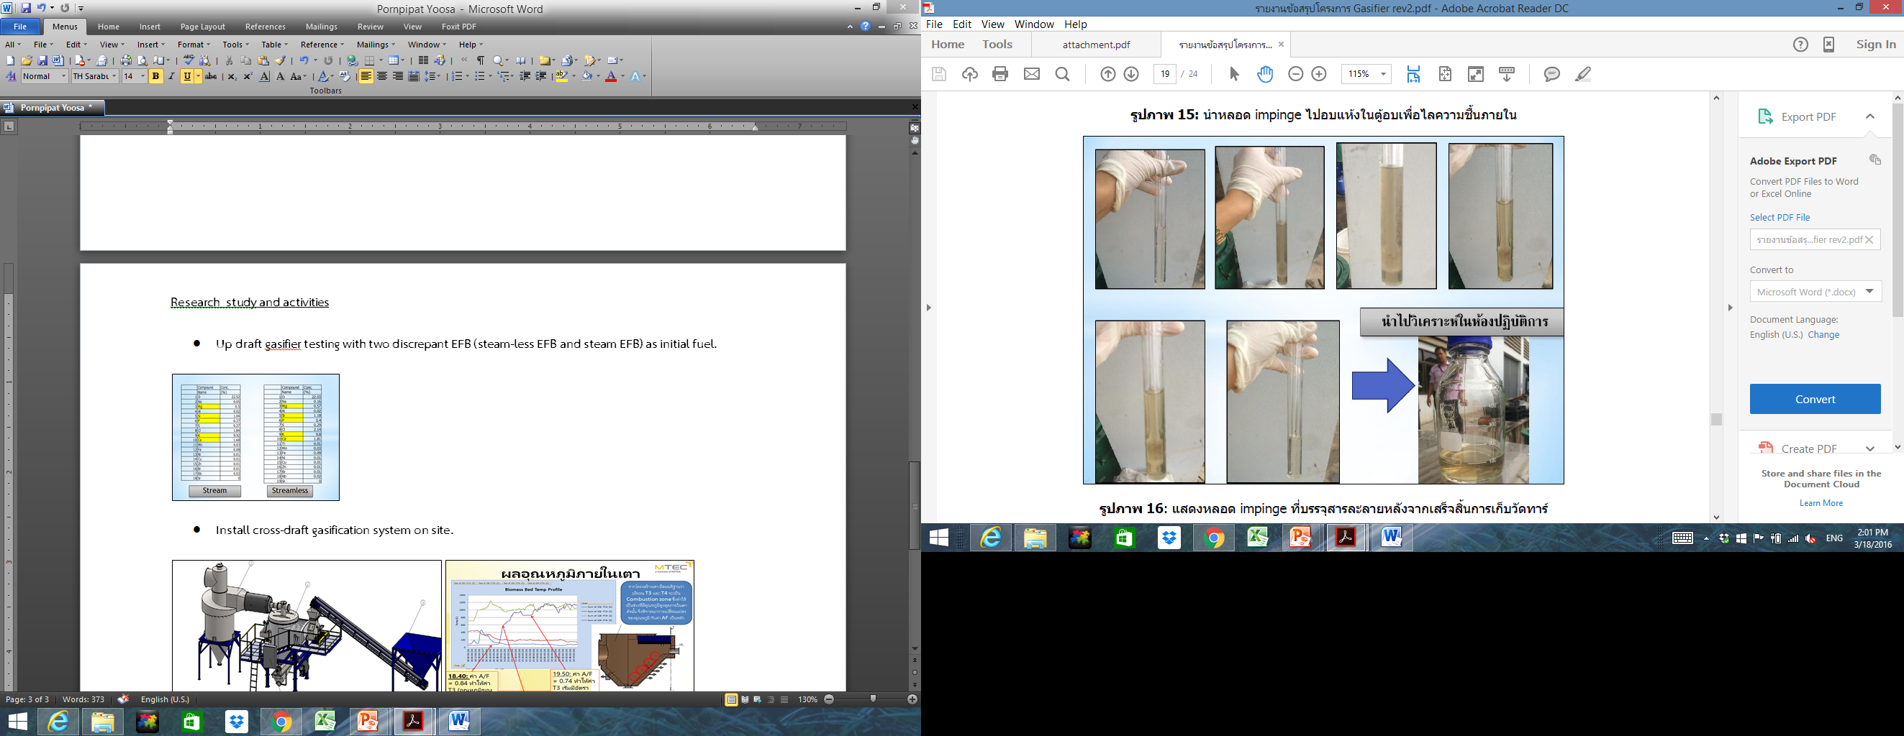 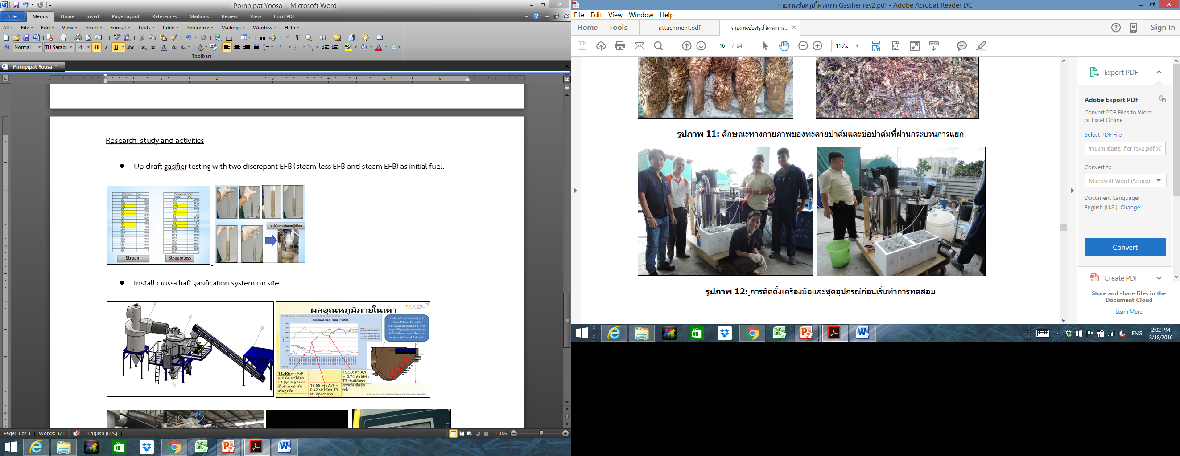

* **Install cross-draft gasification system on site.**

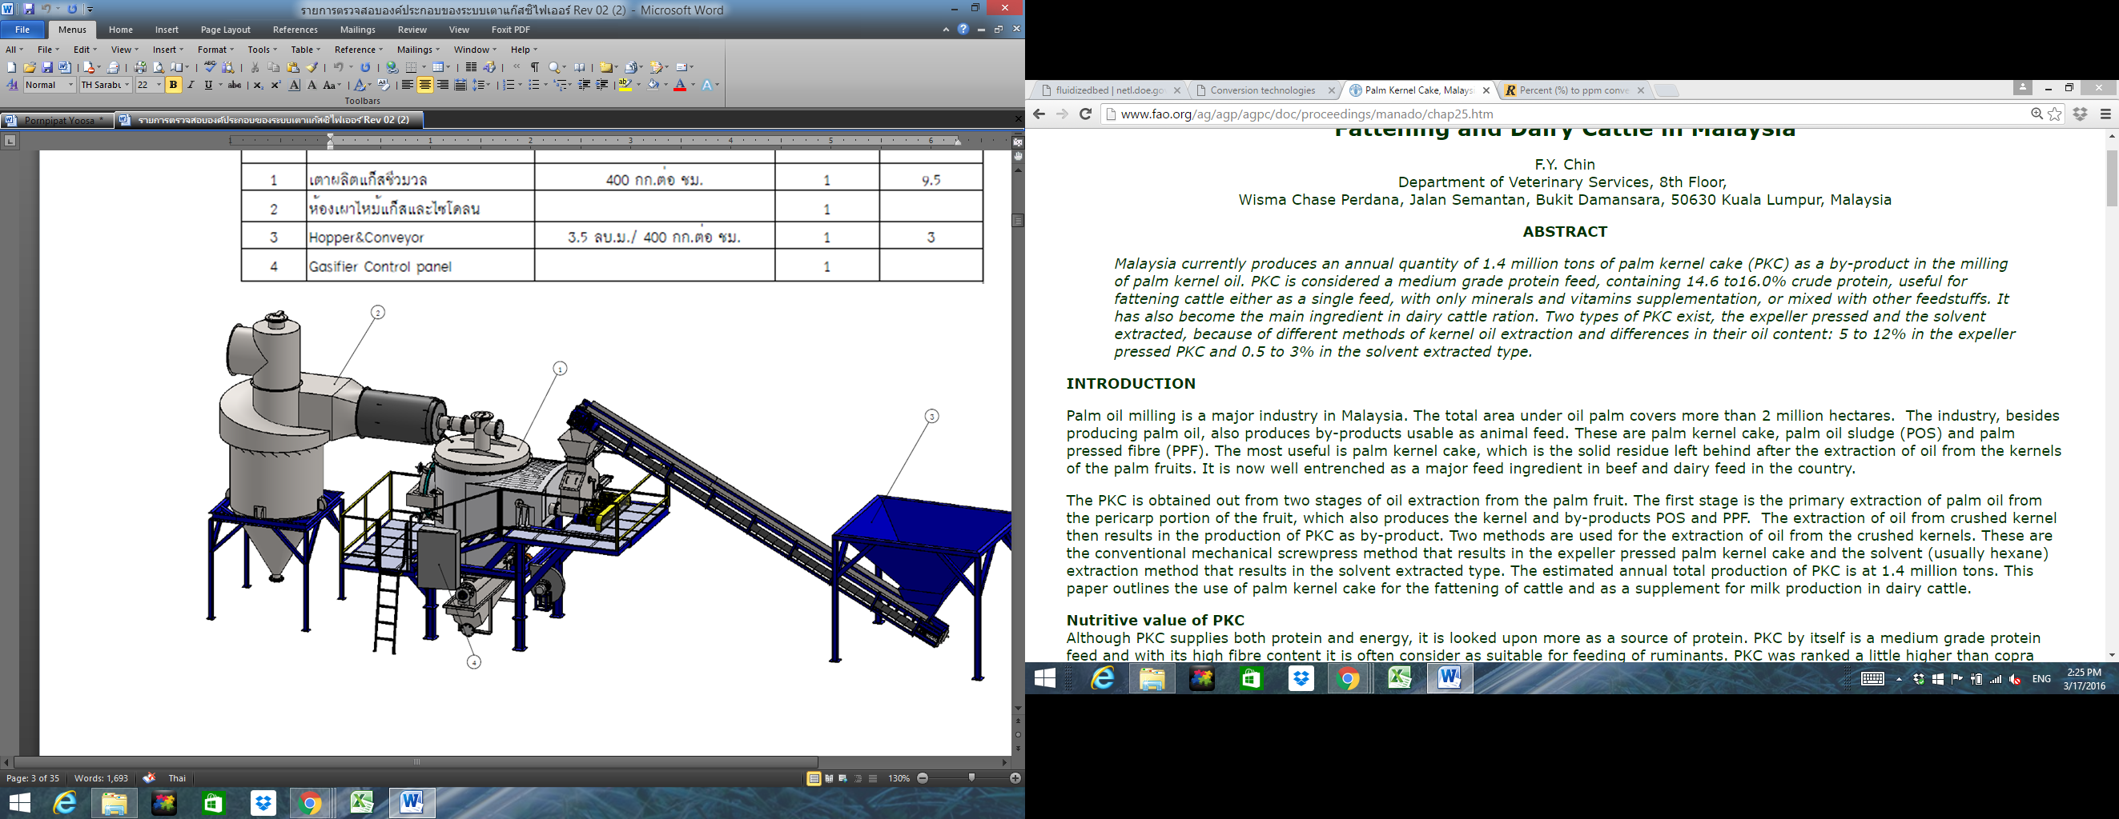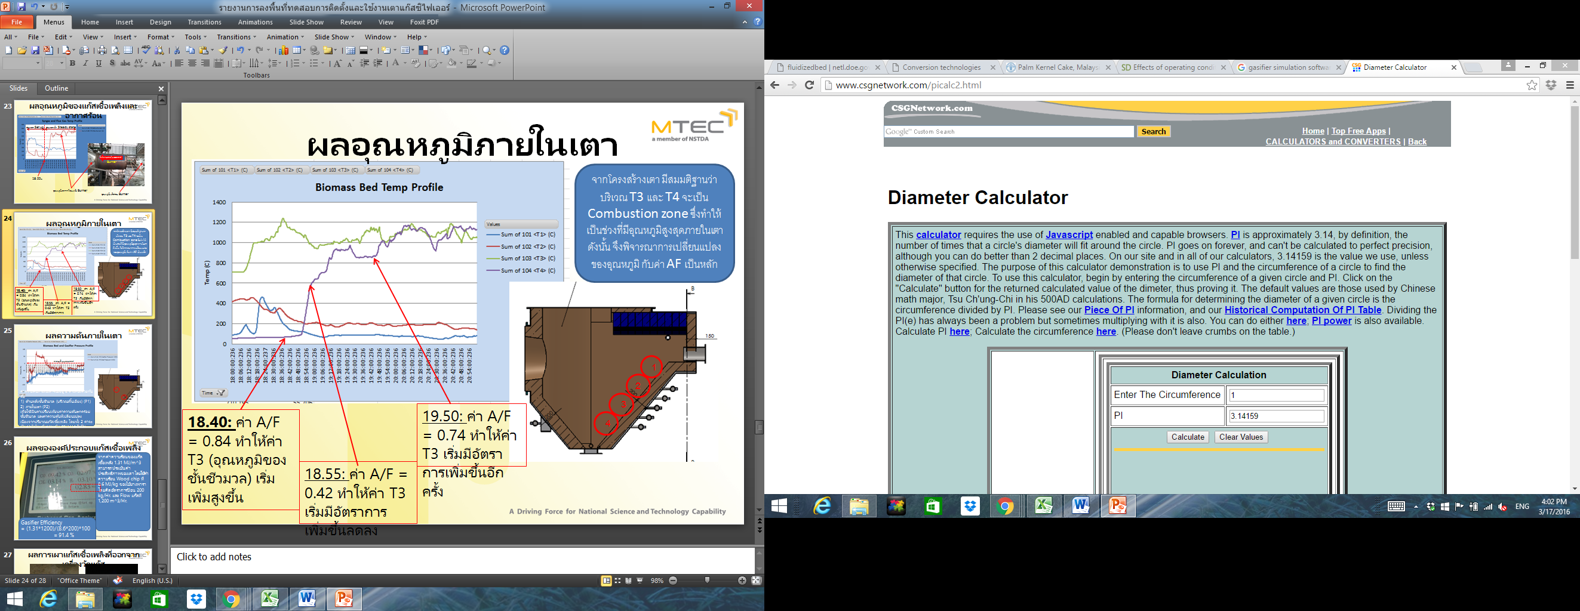

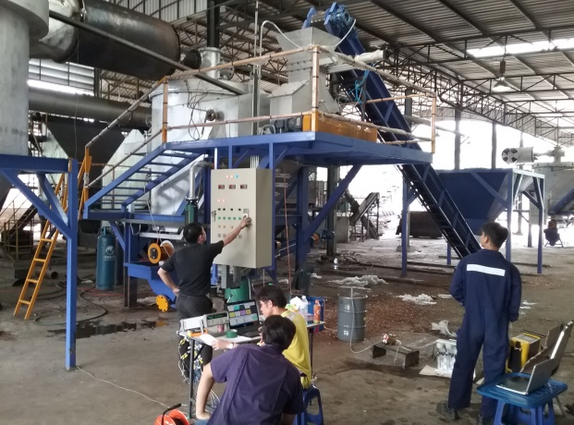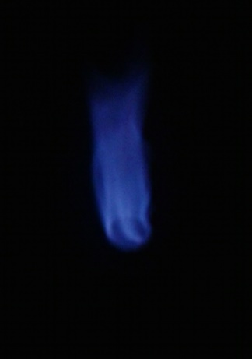 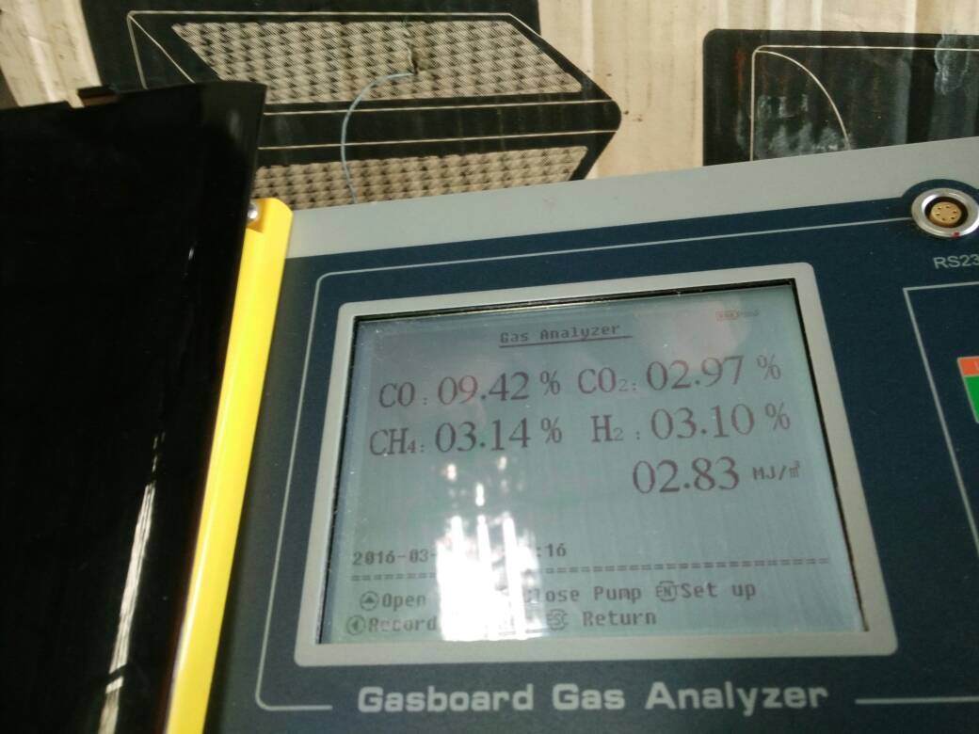

**Transcript**

